What is FoodShare?
FoodShare is a waste reduction program that connects community organizations with schools to reduce waste in schools. School representatives will select and coordinate with a community organization (food pantry, shelter, church, etc) to schedule pick-ups.
Students will put items that they had taken as part of a reimbursable meal, but did not consume, in the blue FoodShare bins at the end of their lunch period.
After each pick-up school representatives should complete this google form to document the number of food items donated.

Who should complete the Google Form?
The school personnel coordinating donation pick-ups should complete the form. The school may designate an alternate if this is more feasible. Please coordinate with your school dining manager to ensure forms are submitted only one time per donation.

When should the Food Redistribution Google Form be completed?
The Form should be completed and submitted every time food is redistributed. Please identify the number of each food item that is being donated. List any items that are not called out (cereal, benefit bars, etc.) in the “other” section. Forms may be submitted as often as needed.

What should go in FoodShare bins?
Bins should contain items students have taken to make a fully reimbursable meal that they did not eat. Donations are limited to non-perishable food items and fresh produce. Any foods, with the exception of fresh produce, that do not have a package should not be included in the donation.

YES foods include, but are not limited to: Oranges, bananas, whole apples, muffins, graham crackers
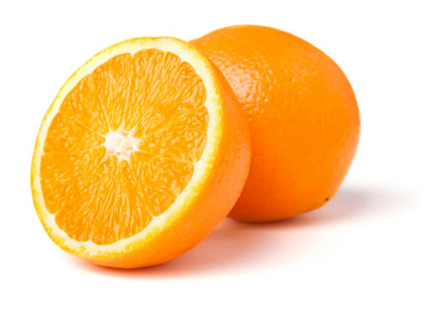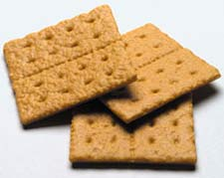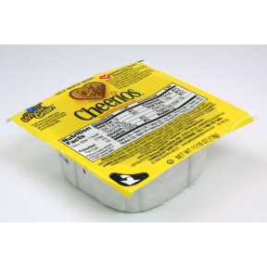

NO foods include, but are not limited to: Yogurt, milk, hot entrees, cold entrees, fruit cups
